Scenario 1: SBE-703.1 applicant that has NOT received an absentee ballot:
- When the voter contacts the office about their political party primary change:
  - Identify the voter in VERIS and add a comment to the voter’s record that a change in political party participation is pending. The comment will assist in eliminating a phone call by an unfamiliar processor when the applicant’s new SBE-703.1 form is submitted.
  - Tell the voter:
    - The voter needs to complete an SBE-703.1C application. Direct the voter to ELECT’s “Voter Forms” page: https://www.elections.virginia.gov/registration/voter-forms/ where they can print the Virginia Permanent Absentee Ballot Change Application (SBE-703.1C).
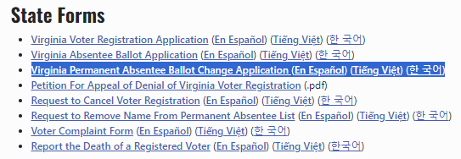
    - The voter needs to pay close attention to the options and instructions in sections 3 and 5.
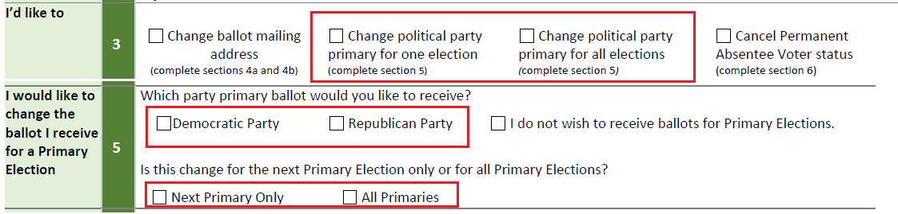
    - The voter may submit a completed SBE-703.1C form by either emailing or mailing the completed form to the general registrar’s office.
    - There is a 3-day processing window on submitted applications and mailed ballots will take 3-5 days to arrive once absentee voting starts.
- Once the SBE-703.1C form arrives, perform an “Absentee Search” in VERIS using the applicant’s 703.1C application (VERIS Home page > Absentee > Absentee Search).
  - On the voter’s Absentee History page, click on the “Add Application” button.
  - On the voter’s Add Application page:
    - Select the appropriate political party primary from the “Election” drop-down menu
    - Select the “Temporary Change of Info – SBE 703.1C” from the “Application Type” drop-down menu
    - Enter “Application Received Date”
    - Enter the appropriate “Received by Method” from the drop-down menu
    - Click “Save”.
  - Return to the voter’s Absentee History page (VERIS Home page > Absentee > Absentee Search).
    - In the Absentee Ballots section (bottom of page), click on the pencil icon for the initially approved primary election ballot and ABS ballot labels that need to be deleted.
  - On the Absentee Ballot Maintain page:
    - Clear the “Ballot Received Date” field.
    - In the “Received by Method” dropdown, select the blank area at the top to clear the field.
    - Select “Deleted” from the “Ballot Status” drop-down menu.
    - In “Ballot Status Comment” enter “Voter submitted an SBE-703.1C change form.”
    - Click “Save”.

Scenario 2: SBE-703.1 applicant that has received an absentee ballot:
- Direct voter to return to the correct mailing address (i.e., not the BRM or QBRM mailing address):
  - The unopened absentee ballot envelope
  - An SBE-703.1C application with the desired political party primary selected (See illustration in Scenario 1, item 1 on the first page).
    - NOTE: The voter is responsible for mailing the unused ballot back to the office. Title 24.2 only covers postage for returning voted ballots.
    - Another recommendation would be to offer the voter to return the unvoted ballot in person during early voting.
- Follow the VERIS SBE-703.1C application processing steps outlined in Scenario 1 on the first page.
- Secure the unused absentee ballot envelope in a secure place within the office. This envelope, along with other abandoned primary ballot envelopes will go to the CAP officers on Election Day. They will seal the envelopes in an Envelope #4 Spoiled\Void Ballots.

Best Practices: Make absentee application processing staffers aware that in a dual party primary absentee voters are allowed to change their minds in selecting a political party primary as this document indicates. This may resolve or reduce the need to reprocess an application(s) processed as a “Denial or Duplicate.”
Staff should attempt to coordinate the simultaneous return of the SBE-703.1C form along with the unvoted ballot as much as possible to avoid missed political party ballot changes.

