CAP Election Day Guide
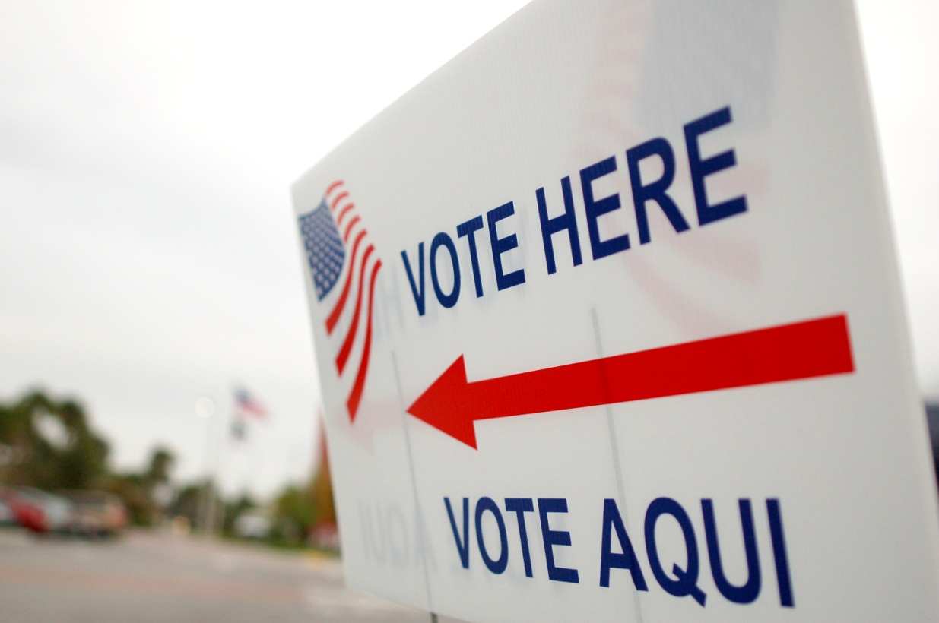

CAP Election Day Guide

TABLE OF CONTENTS

1. What Every CAP Election Officer Needs to Know 3
Duties of Every CAP Election Officer 3
The Central Absentee Precinct (CAP) Procedures (§24.2-709.1 and §24.2-712) 3
Persons Allowed Inside the Polling Place (§24.2-604) 4
Prohibited Polling Place Activities (§24.2-604) 4
Terminology 4
2. The Chief Officer 5
Timeline/Task Checklist 5
CLOSING THE POLLS 7
3. The Check-in Officer 9
Item Checklist 9
Ballot Processing Procedure 9
4. The Pollbook Officer 13
Item Checklist 13
Accepted Ballot Procedure 13
After the Polls Close 13
5. The Ballot Officer 14
Item Checklist 14
Accepted Ballot Procedure 14
6. Processing Ballots 15
Rejected Ballots Procedure 15
Unused Ballot Procedure 16
HAND-COUNTING BALLOTS PROCEDURE..……………………………………………………………………………………………………………… 17
7. After the Polls Close (Generally) 18
Task list 18
8. Packing Envelopes and Boxes 20

What Every CAP Election Officer Needs to Know

Duties of Every CAP Election Officer
- Read this entire handbook prior to Election Day. Each member of the team must also be familiar with the State Board of Election’s (SBE) absentee ballot regulations (1 VAC Chapters 45 and 70).
- Arrive at assigned polling place no later than the designated time.
- The CAP is operated under the direction of the Chief Officer. They will assign duties to every election officer.
- It is imperative that the polls open on time (§24.2-712F) and close at 7 p.m. The CAP must open at 6 a.m. unless a later opening time has been officially established.
- Remain until instructed to leave.
- Do not leave the CAP on Election Day without permission from the Chief, Assistant Chief or General Registrar.
- Process all the absentee ballots.
- Review and sign the “Statement of Results” (SOR) before leaving for home.
- Assist in the various closing procedures.

The Central Absentee Precinct (CAP) Procedures (§24.2-709.1 and §24.2-712)
- CAP Officers work in either two-member teams, consisting of a Pollbook Officer and a Ballot Officer, or three-member teams that also include a Check-In Officer. There may be as many teams as needed to process the number of ballots received.
- Typically, the CAP teams will complete processing one precinct or election district before moving on to the next precinct or election district, depending upon the particular type of election.
- Ballots to be processed will include machine-readable ballots, ballots that have been mistreated somehow so they will not feed through the scanner, UOCAVA Ballots and FWABs.
- Ballots that cannot be read by the scanner must be set aside for hand-counting, which cannot begin sooner than noon. UOCAVA Ballots generally fall in this category, as do FWABs.
- Hand-counted ballots will be processed by their own team.
- Any absentee ballot received after Election Day but before noon on the third day after the election and is postmarked on or before Election Day – if the voter is found entitled to vote (§24.2-709 B) must be counted.

  - How the optical scan ballot will travel
Check-in
Officer
Ballot
Officer
Pollbook
Officer
Ballot
Box
Voting
Machine

Persons Allowed Inside the Polling Place (§24.2-604.3 -- .§24.2-604.6)
- Qualified voters
- Non-voting candidates may visit the polling place no longer than ten (10) minutes per day per polling place
- Those assisting qualified voters
- Minors age 15 or younger when accompanied by a parent
- Any member or authorized representative of the Electoral Board
- Any member or authorized representative of the State Board of Elections
- Officers of Election
- An authorized party representative (see § 24.2-604.4)
- An authorized candidate representative (see § 24.2-604.4)
- Voting equipment custodians
- News media representatives (see §24.2-604.5B)
- Neutral Observers as authorized in writing by the Electoral Board (see §24.2-604.5A)
- Election Pages
- Minors voting in a simulated election (see §24.2-604.6)

Prohibited Polling Place Activities (§24.2-604)
- Any form of campaigning or electioneering
- Giving, tendering, or exhibiting any ballot, ticket, or other campaign or referendum material to any person
- Attempting to influence or solicit any person in casting his or her vote
- Unauthorized assistance with voting
- Hindering or delaying any Officer of Election or voter
- Wearing any indication that they are authorized to help voters by Neutral Observers, candidates, or other party representatives, except interpreters, inside or within 40 feet of the polling place

Terminology
Election district | The area which is represented by an official when elected by the voters. The location of a voter’s home address determines the election district, precinct, and polling place where the voter is eligible to vote. A voter’s ballot typically involves one election district, though it may involve a combination of two or more election districts.
Ballot style | This refers to both the ballot content (offices, candidates, issues) and the type of election (primary, general, special election, etc.).
Final Absentee Report  (aka AB List or AB Pollbook) | The list of voters who were issued an absentee ballot. Officers in the CAP will use a computer-printed AB list and, if applicable, a separate hand-typed or written AB list for  - Emergency absentee ballot applicants (§24.2-705)  - Federal only absentee applicants  - Presidential only absentee ballot applicants
Return envelope | Outer envelope of the ballot pack that went through the mail and is returning the ballot to the office. It may contain a return address sticker with all the voter’s information.
Statement of Results  (SOR) | The document on which the results of the election are ultimately compiled.

2. The Chief Officer

Timeline/Task Checklist
BEFORE ELECTION DAY
Check the Supply List against supplies received
Arrange the polling place (if possible)

ON ELECTION DAY:

 | q Arrive at CAP at the designated time.
q Welcome authorized representative(s).
- Check the written authorization designating the individual as a representative. It must be:
  - a written statement or a photocopy of a written statement
  - signed by the appropriate person (see “Do’s and Don’ts for Campaigners and Authorized Representatives”)
- Have the Registrar verify that the authorized representative is a qualified voter in Virginia.
 | q Check supplies against the supply list (unless done previously)
q Complete “Oath of Officer” form:
- Administer the Oath to all Officers.
- Make sure all Officers sign the “Oath of Officer” form.
- Sign and complete the section at the bottom of the “Oath of Officer” form.
- Place the “Oath of Officer” form in Envelope #2.
q Arrange polling place (unless previously done).
q Assign Election Officer duties.
q Confirm that returned ballot envelopes, AB list, and pollbooks are set up and
organized for processing.
q Set up the voting machine(s) for absentee ballots:
- Verify that voting machine serial numbers, and any security seal numbers, match numbers on Envelope 7/7C.
- Open the machine according to the provided instructions.
q Confirm that the voting machine opening tapes show the appropriate
election, the correct candidates and issues, and show “0” votes have been
cast. Call the Registrar if there is a discrepancy.

- Have two Officers sign any opening tapes that have not been signed.
- Leave the tapes attached to the voting machines or do as instructed.
q Set up voting machines which were used for in-person AB voting and for
pre- processing AB voting, if appropriate. Confirm that you have all
paperwork and machine tapes for these voting machines. These will be
processed after 7 p.m. when the polls are closed.
q Count and record on the SOR the number of unused ballots provided by the Registrar
for use by qualified absentee voters (if required).
q Count and record on the SOR the number of returned absentee ballots delivered by
the Registrar (if required).
6:00 a.m. | Announce “The polling place is open.”
While the Polls are Open | - Oversee progress of absentee ballot processing.  - Ensure numbers are accurate as each ballot combination/election district or precinct is completed.  - Welcome any additional authorized representatives who may arrive after the polls open.  - Any time after noon tallying of the hand-counted ballots shall begin. Officers sign another Oath. (§ 24.2-712)
 | - Ensure that any rejection of an absentee ballot is discussed with you, the members of the team, and other Officers. [See §24.2-711, 1 VAC 20-70-20, 1 VAC 20-70-40]
NOTE: | - Remember, DO NOT run the voting machine result tapes until after:  - the polling place closes at 7:00 p.m.;  - all absentee ballots have been processed; AND,  - all acceptable ballots have been inserted into the voting machine(s).

  - Attending to a Voter with an Unused or Defaced/Void Absentee Ballot (§24.2-708)

- A qualified voter may cast a regular ballot if:
  - The voter returned the unused ballot to an Officer of Election at the CAP on Election Day.
  - The voter returned his unused ballot to an Electoral Board member on Election Day.
  - The pollbook shows the voter returned the unused ballot by mail or in person to the Registrar or Electoral Board before Election Day.
Note: The law allows a voter who returns an unused or accidentally spoiled ballot to vote normally on equipment at the CAP or assigned polling place. However, return of the ballot must be confirmed by an Officer of Election, General Registrar or Electoral Board member. In most cases, the pollbook will provide the necessary confirmation. If no confirmation is possible, the voter must vote a provisional ballot.

Attending to a Voter who Lost or Did Not Receive his Requested Absentee Ballot (§24.2-708(B) last sentence)
- A qualified AB voter must cast a Provisional Ballot if he lost or never received the ballot.

CLOSING THE POLLS
Close Polling Place | - At 6:45 p.m., verify the correct time, announce polls closing in 15 minutes (§24.2-603).  - At 7:00 p.m., verify the correct time and announce, “This polling place is officially closed.”
Authorized Reps | q Welcome authorized representatives.  - Remind authorized representatives that they cannot leave until unofficial results are announced (§ 24.2-655).  - Check their written authorization designating the individual as a representative. It must be:  - a written statement or a photocopy of a written statement  - signed by the appropriate person (see “Do’s and Don’ts for Campaigners and Authorized Representatives”)  q Have the Registrar verify that the authorized representative is a qualified  voter in Virginia.
Provisional  Ballots in  Ballot Containers | - Supervise the unlocking and opening of the emergency ballot container.  - Supervise the processing of the Provisional Ballots (green envelopes).  - Remove and count, but do not open, sealed Provisional Ballots, if any, and place them in the larger green 1A Envelope.  - Enter the number of Provisional Ballots enclosed in the certification section on line 1 on the back of the 1A Envelope. If there are no Provisional Ballots, do not write anything on the envelope.  - Have two Officers sign the certification section if there are any votes. If there are no Provisional Ballots, Officers may instead complete the Empty Envelope Certification and enclose that in Envelope 2.  - Check all ballot containers and envelopes to ensure that all ballots have been processed and counted or sent to the Electoral Board as a Provisional Ballot.
Results tapes  and Worksheets for Write-ins and/or Hand-counted Ballots | - Supervise Recording the Results: supervise obtaining results tapes from all the voting machines following the instruction provided.  - Print at least three results tapes from each machine  - Have at least two Officers complete the information and sign the results tapes in the spaces provided (if not already done).  - Attach Tape 1 from each machine to the first SOR.  - Attach Tape 2 from each machine to the second SOR.  - Attach Tape 3 from each machine to the Printed Return Sheet (ELECT-658).  - Attach Zero Tapes to each SOR but NOT to the Printed Return Sheet.  - If additional tapes are run, return as instructed.  - Close the voting machines by following the instructions provided.  - Using two teams, record the election results from the machine tapes on the Worksheets for the SORs.  ● Record the results for Hand-counted Ballots and Write-ins on the Worksheets for  SORs.  ● Tally the results from the Worksheets; record on SORs.
Announcing Unofficial Results | - The Chief (or designated Officer of Election) calls in the unofficial results to the Electoral Board or General Registrar’s office.  - Announce unofficial results inside and outside the polling place. If media representatives or others are waiting for the unofficial results, they may leave at this time.  - Complete and review the SOR. All Officers present must sign.
Making Final Checks | - Election Officers remove signs inside and outside the polls.  - Supervise packing of election materials in the supply containers.  - Insure that all numbered envelopes contain correct materials.  - Leave polling place clean and organized.  - Secure the polling place.

The Check-in Officer

Item Checklist
- Returned absentee ballots in envelopes
- Pens
- Ruler
- Rejected or unused ballots containers
- Envelope opener

Ballot Processing Procedure
- Process all returned absentee ballots from one ballot combination/election district or precinct, or as instructed, before moving on to the next.
- Begin with the first return envelope contained within the returned absentee ballot container.
  - Set aside “Federal Write-in Absentee Ballots” (FWABs) for evaluation later
  - Set aside non-machine readable UOCAVA ballots for processing as hand-counted ballots

- Read out loud the voter’s name, listed on the top left corner of the return envelope. The Pollbook Officer confirms that the voter is on the AB list. Check-In Officer also reports if “NA” or “ID” is on the label. Further investigation is necessary if either of these is indicated.
- The Check-in Officer slits open the outside envelope and removes Envelope B from the return envelope. Do not open Envelope B.
- Examine the Statement of Absentee Voter on Envelope B to determine if the oath is complete. See Table 3B “Reasons for Rejecting Absentee Ballots” for required information. Also note the guideline below:
  - Section 24.2-706, Code of Virginia, provides that, “When this statement has been properly completed and signed by the registered voter, his ballot shall not be subject to challenge pursuant to § 24.2-651.”
- Confirm that the voter’s name matches the name listed on the AB list; the address matches the VERIS printed return address label, and the statement is signed by the voter.
Note: If the name listed on the AB list and the name listed on the statement are not identical,
the Officers must be satisfied that the two names are, in fact, one and the same person,
applying the standards provided in SBE’s regulations. 1 VAC 20-70-20 (Envelope B) and 1 VAC
20-45-20 (FWAB). For example, SBE regulations require counting an otherwise qualified
Envelope B signed “William D. Jones” for a voter listed on the AB list as “William Daniel Jones.”

Illustration 3A. Envelope B Information Block
Regular Ballot Envelope:
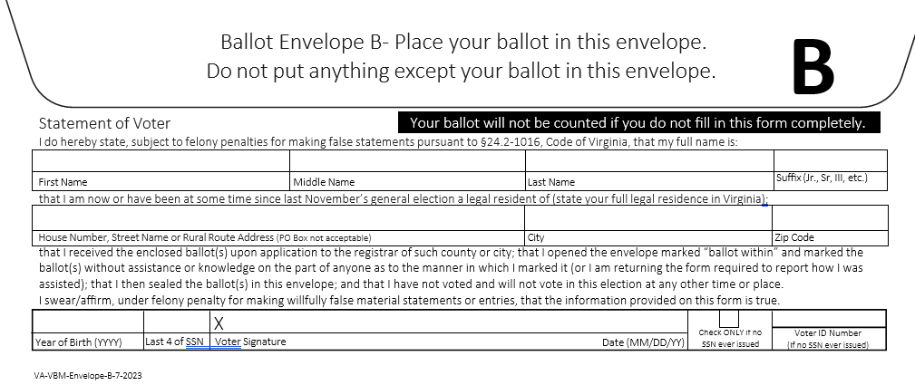

UOCAVA Ballot Envelope:

  - 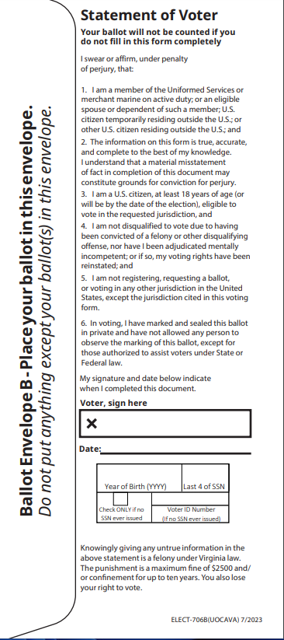

  - Table 3B. Reasons for Rejecting Absentee Ballots
See 1VAC20-70-20; 1VAC-70-40; 1VAC20-45-20; 1VAC20-45-40.
If the voter, | The ballot must be rejected | The Ballot must NOT be rejected
(Info from Registrar): Is no longer registered to vote. Reasons may include transfer to another locality prior to Election Day, transfer out of state, conviction of a felony, or adjudication of mental incapacity. | X
(Info from Registrar): Has requested assistance in marking the ballot and has omitted the assistance form. |  | X
(Envelope): Voter has a completed assistance form, but assistant failed to write “Voter Unable to Sign,” “Blind Voter,” or some other indication that the voter could not sign. |  | X
(Envelope, NA for UOCAVA): Omitted her first name or first initial; unless the first name is listed in another name place other than “First” (e.g., their first and middle names are listed in the “middle” name place). | X
(Envelope, NA for UOCAVA): Omitted his middle name or initial if full first and last name listed. |  | X
(Envelope, NA for UOCAVA): Omitted her last name | X
(Envelope, NA for UOCAVA): Has listed her full name in an order other than “Last, First, Middle” |  | X
(Envelope, NA for UOCAVA): Has listed the initial for the first name instead of her full first name, as long as the full middle name is provided |  | X
(Envelope, NA for UOCAVA): The voter omitted his generational suffix when one or more individuals with the same name are registered at the same address, and it is impossible to determine the identity of the voter | X
(Envelope, NA for UOCAVA): Has listed a derivative of her legal name as her first or middle name (e.g., “Pat” instead of “Patricia”) |  | X
(Envelope, NA for UOCAVA): The name listed on the AB list and the name listed on the envelope are not identical; as long as you and the Officers on your team are satisfied that the two names are the same person. (e.g., a voter may be listed on the AB list as “William Daniel Jones,” but the voter might have signed “William D. Jones.”) |  | X
(Envelope, NA for UOCAVA): Omitted her house number and street name. Or alternately, if the voter uses a rural route address, omitting her rural route address shall result in rejection. | X
(Envelope, NA for UOCAVA): Omitted her residential street identifier (i.e., “Street,” “Drive,” “Avenue,” etc.) |  | X
(Envelope, NA for UOCAVA): Omitted her city and zip code. | X
(Envelope, NA for UOCAVA): Omitted her zip code, as long as the city is listed |  | X
Envelope (NA UOCAVA): Omitted her city, as long as the zip code is listed |  | X
(Envelope): Omitted her signature | X
(Affidavit): If voter provided an AB Cure Voter Affidavit that includes information missing from the previous three categories (signature, year of birth, SSN4): |  | X
(Envelope): Has listed an incorrect date on which he/she signed Envelope B |  | X
(Envelope): Omitted the date he/she signed Envelope B |  | X
(Envelope): The signature of the voter is illegible |  | X
(Envelope): Returned the ballot in Envelope B without the return envelope |  | X
(Envelope): Return envelope is missing a postmark or the postmark is illegible, but the ballot was received by mail before noon on Friday after the election (unless Friday is a holiday, in which case, ballot must be received by Monday after the election) |  | X
(Seal): Has returned Envelope B improperly sealed, as long as the outer envelope with Envelope B and the ballot arrived sealed |  | X

Illustration 3C. Entering REJ Number and Reason for Rejection on Envelope B
↓ Blank side of Envelope B ↓
REJ-4
Voter did not provide name and address within the Statement.

Signature of at least two Officers of Election, one representing each political party

The Pollbook Officer

Item Checklist
- AB pollbooks (final AB applicant list) or electronic pollbook(s)
- Pollbook count sheets
- Pens
- Ruler

Accepted Ballot Procedure
- Locate the voter’s name in the pollbook. Repeat the voter’s name and address. Mark off the next number on the pollbook count sheet and enter the marked-off pollbook count number in the pollbook under the “Vote Rec” column opposite the voter’s name.
- Check-in Officer hands return envelope and Envelope B to Pollbook Officer.
- Confirm that the Statement of Absentee Voter on Envelope B has been completed and signed, including the voter’s Year of Birth and SSN4.

- Continue this procedure for each absentee ballot that is accepted.
- If using electronic pollbooks for CAP, follow instructions provided for checking in voters as they are processed.

After the Polls Close
- Certify that the polling place is closed.
- After the polls close, complete the certification section of each pollbook count sheet. If using electronic pollbooks, complete the electronic pollbook certification sheet.
  - Enter the last number marked off the pollbook count sheet in the certification section.
  - Sign the “Pollbook Count Certification” form.

The Ballot Officer

Item Checklist
- Letter opener
- Official ballot box
- Emergency ballot box
- Stapler, staples
- Container for empty envelopes
- Box/Envelope #5
- Red pen
- Black or blue pen

Accepted Ballot Procedure
- Receive the return envelope and the unopened Envelope B from the Pollbook Officer.
- Confirm that the Statement of Absentee Voter on Envelope B is completed, signed and dated.
- Using a letter opener, carefully slit open Envelope B.
- Remove the folded ballot but do not unfold it. Ensure that there is only one ballot. Do not look at the votes cast. Limit examination to the following:
  - For UOCAVA ballots printed by the voter, the ballot may be printed on a plain piece of paper without an Electoral Board seal. On the blank side of the ballot, in red pen, write “UOCAVA” and deposit in the Emergency Ballot Box for hand-counting.
  - NOTE: If a returned ballot is not an official ballot or does not meet the UOCAVA exception, replace the ballot in the B Envelope, place the B Envelope in the return envelope and place in the rejected ballots container for later inspection. At least two Officers of Election are needed to determine whether to reject the ballot.
- Place the machine-readable ballot into the ballot container.
- If you have a non-machine-readable ballot, place it in a separate container.
- When all ballots from one ballot combination, district, or precinct have been processed, complete the information on the ballot count report or Precinct Worksheet, if used.
- When all ballots from one precinct or district have been processed, insert the machine-readable ballots into the voting machine. Use a worksheet to track the number of ballots processed, as hand-counts or fed into the voting machine.
- Repeat for the next ballot combination, district, or precinct.

Processing Ballots

Rejected Ballots Procedure

Item Checklist

- Ballot envelopes to be reviewed
- SBE Omissions List
- AB pollbook
- Rejected AB count sheets
- Rejected AB log
- Rubber bands
- Pens
- Stapler and staples
- Ruler

- Check-In Officer reads the name of the voter and examines the voter statement on Envelope B.
- Pollbook Officer receives the return envelope and unopened Envelope B from the Check-in Officer.
- Pollbook Officer confirms that voter is on pollbook and reads the voter’s name and address.
- Officers examine the statement of absentee voter on Envelope B.
- Officers determine reason for rejection.
- Pollbook Officer marks off next available number on the AB Rejection Pollbook Count Sheet
and records it on the pollbook in “Vote Rec” column; writes the initials of the voter above the marked off number on the AB count sheet; and writes the rejection reason to the right of the voter’s name on the AB pollbook.
  - Do not mark off a regular pollbook count number
- Pass the return envelope and the unopened Envelope B to the Ballot Officer.
- Place in Box for Envelope 5.
  - Illustration 6A. Rejected AB Count Sheet
C, A J  REJ – 1 | R, L M  REJ – 2 | S, K H  REJ – 3 | S, L H  REJ – 4 | REJ – 5
REJ – 11 | REJ – 12 | REJ – 13 | REJ – 14 | REJ - 15
REJ – 21 | REJ – 22 | REJ – 23 | REJ – 24 | REJ – 25

  - Illustration 6B. Showing Rejection and Unused Ballot Reasons on AB Pollbook

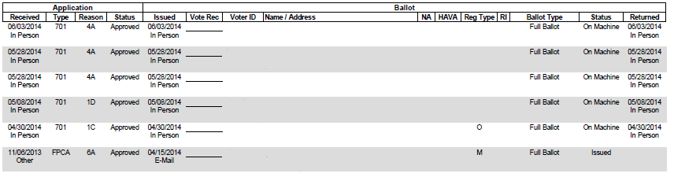
Marked 11/04/2014
Unused-3
Marked 09/28/2014
Unused 11/04/2014
REJ-4
CADABBY, ABBY
1234 Sesame St.
1234565
1234561
1234562
1234563
SNUFFLEUPAGUS, ALOYSIUS
1232 Sesame St.
1234564
1234566
MONSTER, ELMO
1235 Sesame St.
GROUCH, OSCAR
1231 Sesame St.
BIRD, BIG
1236 Sesame St.
MONSTER, COOKIE
1233 Sesame St.

Unused Ballot Procedure
Items Checklist
- Container with unused ballots
- AB Pollbook
- Unused AB Count Sheet
- Letter Opener
- Pens

    - Confirm that the voter’s name listed on the outside envelope matches the name on the AB pollbook.
    - Confirm that a date has been entered on the AB pollbook in the “Returned” column. If a date has not been written, enter the date of the election. In the Status column, write “Unmarked.”
    - Leave envelopes A and B and any other contents unopened inside the outer envelope.
    - Enter the voter’s initials (Last, First, and Middle) above the next consecutive number on the “Unused Absentee Ballot Record” form for that election district or ballot style (see below).
    - Do not mark off a regular pollbook count number.
    - Pass the envelope containing the unused ballot to the Ballot Officer.
Leave envelopes A and B and any other contents unopened inside the return envelope.

Illustration 6C. Unused AB Count Sheet
M, G G  UNUSED – 1 | T, R U  UNUSED – 2 | S, L H  UNUSED – 3 | UNUSED – 4 | UNUSED – 5
UNUSED – 11 | UNUSED – 12 | UNUSED – 13 | UNUSED – 14 | UNUSED - 15

Illustration 6D. Unused Ballot Marking on Returned Envelope

Postmaster  Electoral Board of …  Address |  | CERTIFICATE OF MAILING  REQUIRED
UNUSED -3  SLH |  | To:

Hand-Counting Ballots Procedure
- CAP Officers work in either two-member teams, consisting of a Pollbook Officer and a Ballot Officer, or three-member teams that also include a Check-In Officer. There may be as many teams as needed to process the number of ballots received.
- CAP Officers shall begin tallying hand-counted ballots at any time after 12 noon on the day of the election. However, any persons tallying may not use cell phones or any other communication devices during such tallying and until the close of polls. CAP Officers who begin tallying during this time period must sign an oath that they will not transmit any counts prior to the closing of the polls. (§24.2-712)
- Typically, the CAP teams will complete processing one precinct or election district before moving on to the next one. Tally hand-counted ballots on Worksheets as instructed. Complete the tally sheet recording the results of the hand-count.
● Secure the hand-counted ballots together with a paper clip or rubber band and place them in
Envelope 3 or Box 3. Label the election district each group represents.

After the Polls Close (Generally)

Task list
Recording Write-in Ballots (not applicable in Primaries) | - If no write-in votes are cast, write “none” on the “Write-in Certification” form and skip the instruction below.  - Record the TOTAL of write-in votes from optical scan voting machines as well as from hand-counted ballots on your SOR Worksheet. The Electoral Board will determine how these votes are distributed between candidates if there seem to be differing versions of the same candidate’s name.  - If there are votes on non-machine-readable ballots that appear to be for the same person, but voters have used different versions of the same name, create a separate total for each version of the name. For instance, 10 votes for “Robert G. Wilson”, 5 votes for “Bob G. Wilson” and 1 vote for “Bob Wilson”, would be totaled separately, instead of being counted as 16 votes together. This is because the Electoral Board has sole discretion to determine voter intent in these instances.
Documenting Both Copies of the Statement of Results (SOR) | q Check the Statement of Results (SOR):  о Verify the voting machines serial numbers (if required).  о Verify the voting machines information (if required).  о Verify the public counter number was at “0” on the opening tape and  recorded on the SOR (if required).  о Verify the protective counter at the start of in-person voting is recorded on  SOR (if required).  о Verify the in-person voting numbers from the tapes.  о Verify the by-mail voting numbers from the tapes.  о Verify that hand counted ballots were tallied on a Tally Sheet and recorded on  the SORs.  о Verify the write-in vote totals were recorded on the SORs.  о Verify the number of rejected voters is correct from the Worksheet.  - Prepare SOR #1  - Attach one set of tapes (with Zero tape) from the voting machines to SOR #1.  - Have all Officers at the polling place sign SOR #1.  - Prepare SOR #2  - Attach second set of tapes (with Zero tape) from the voting machines to SOR #2.  - Have all Officers at the polling place sign SOR #2.  - IMPORTANT: SOR #1 and SOR #2 must be identical and must be signed by all Officers present at the close of the polling place.  - Call the General Registrar’s office if help is needed.  - Place both copies of the SORs in Envelope 2.
Completing the Printed Return Sheet ELECT-658 | - Have all Officers sign the Printed Return Sheet (ELECT-658).  - Attach third set of tapes to the Printed Return Sheet and place in Envelope #2A.
Packing Boxes and Envelopes | - Check off each box/envelope as it is packed, sealed and signed.  - Confirm that the precinct name/number and election date are printed on each box label/envelope. If necessary, write this information on each envelope.

Packing Envelopes and Boxes
Env./Box Number | Contents | Seal/Signature Requirements
#1A & #1B  (Use #1B ONLY IF INSTRUCTED TO USE) | - Provisional Ballots (sealed green envelopes)  - Provisional Ballots cast after hours by court order extending voting hours | - Enter number of enclosed envelopes  - Sign certification (two Officers*)  - Seal with label  - Sign and date label (two Officers*)  Only complete certification if there are Provisional Ballots contained inside envelope.
#2 | - “Oath of Officer” form  - Pollbook/pollbook count sheets  - Two identical copies of the SOR  - Two identical copies of the Write-ins Certification  - Incident report, if used  - Ballot record report, if used  - Ballot tracking and worksheets  - Results Call-In Sheet | - Seal with label  - Sign and date label (two Officers*)
#2A | - Printed Return Sheet (ELECT-658) with attached machine tapes; All Officers sign | - Seal with label  - Sign and date label (two Officers*)
#3 | - Counted ballots | - Confirm precinct name/number and date on envelope or container  - Seal box with three labels  - Sign and date label (All Officers*)
#4 | - Spoiled Ballots labeled by election district  - Void Ballots labeled by election district | - Sign with Label  - Sign and date label (two Officers*)
#5 | - Empty returned envelopes  - Returned Instructions/ballot guides  - Rejected/unopened absentee ballots  - Returned unused absentee ballots | - Seal with label  - Sign and date label (two Officers*)
#6 | - Unissued paper ballots | - Seal with label  - Sign and date label (two Officers*)
#7 | - Optical scanner memory cards  - Machine seals  - Optical scanner keys | - Seal with label  - Sign and date label (two Officers*)
#8 | - Used Voter Registration Applications  - Used Affirmation of Eligibility forms  - Used Request for Assistance forms  - Used ID Affirmation forms  - Used incident forms | - No seal required
#9 | - Virginia Election Laws | - No seal required
#10 | - Officer of Election name badges | - No seal required
#11  (Hand -deliver to General Registrar) | - Voting machine[s] results tape #4 | - No seal required
#12 | - Duplicates and name mistakes list  - Notification of death of voter | - No seal required

- Place checklists and paperwork not specified above in Envelope 8 or where designated
- * When two Officers are specified:
  - In a general/special election or dual party primary: officers of different political parties
  - In a one party primary: any two Officers

Optional
- If the CAP uses the Empty Envelope Certification (ELECT-Empty Envelope Certification), complete it and include it in Envelope #2. The unused, unmarked envelopes should be returned in the supply case.

- If the CAP uses the Checklist Certification of Materials Used in Election (ELECT-659, -668) form, complete it and include it in Envelope #2. Any unused, unmarked envelopes should be returned in the supply case.

NOTE: Most of the stocks of numbered envelopes are no longer provided by ELECT as stocks are exhausted. A locality may develop its own envelopes. The artwork is in Forms Warehouse.

